 |  |  |  |  |  |  |  |  |  |  |  |  |  |  |  |  |  |  |  |  |  |  |  |  |  |  |  |  |  |  |  |  |  |  |  |  |  |  | Ward No. ____
 |  |  |  |  |  |  |  |  |  |  |  |  |  |  |  |  |  |  |  |  |  |  |  |  |  |  |  |  |  |  |  |  |  |  |  |  |  |  |  |  | Original/Revised
 |  |  |  |  |  |  |  |  |  | Form 1 |  |  |  |  |  |  |  |  |  |  |  |  |  |  |  |  |  |  |  |  |  |  |  |  |  | If revised –
 |  |  |  |  |  |  |  | [See Rule 3] |  |  |  |  |  |  |  |  |  |  |  |  |  |  |  |  |  |  |  |  |  |  |  |  |  |  |  | (i) |  |  | Date of filing
 |  | The Central Sales Tax (Delhi) Rules 2005 |  |  |  |  |  |  |  |  |  |  |  |  |  |  |  |  |  |  |  |  |  |  |  |  |  |  |  |  |  |  |  |  |  |  |  |  | original return ______
 | Return of Sales Tax payable for the quarter under the |  |  |  |  |  |  |  |  |  |  |  |  |  |  |  |  |  |  |  |  |  |  |  |  |  |  |  |  |  |  |  |  |  |  | (ii) |  |  | Acknowledgement
 |  |  | Central Sales Tax Act, 1956 |  |  |  |  |  |  |  |  |  |  |  |  |  |  |  |  |  |  |  |  |  |  |  |  |  |  |  |  |  |  |  |  |  |  |  |  | Receipt No. _________
 |  |  |  |  |  |  |  |  |  |  |  |  |  |  |  |  |  |  |  |  |  |  |  |  |  |  |  |  |  |  |  |  |  |  |  | (iii) Date of discovery of
 |  |  |  |  |  |  |  |  |  |  |  |  |  |  |  |  |  |  |  |  |  |  |  |  |  |  |  |  |  |  |  |  |  |  |  |  |  |  | mistake or error ________
 |  |  |  |  |  |  |  |  |  |  |  |  |  |  |  |  |  |  |  |  |  |  |  |  |  |  |  |  |  |  |  |  |  |  |  | Specify the reasons for revision
R1 Tax Period |  | From |  |  |  |  |  | / |  |  |  |  |  |  |  | / |  |  |  |  |  | To |  |  |  |  |  |  |  |  | / |  |  |  |  | /
 |  |  | dd |  |  |  |  |  |  | mm |  |  |  |  |  |  |  | yy |  |  |  |  |  |  |  | dd |  |  |  |  |  |  | mm |  |  |  |  |  | yy
R2.1 TIN
R2.2 Full Name of Dealer
R2.3 Address
R2.4 Mobile No.
R3 Description of top items you |  |  |  |  |  |  |  |  |  | Sl. |  |  |  |  |  |  | Commodity code |  |  |  |  |  |  |  |  |  |  |  |  |  | Description of goods |  |  |  |  |  |  |  |  |  |  |  | Rate of tax
deal in |  |  |  |  |  |  |  |  |  | No.
(In order of volume of sales for the
 |  |  |  |  |  |  |  |  | 1
tax period or till the aggregate of
 |  |  |  |  |  |  |  |  | 2
sale volume reaches at least 80% -
 |  |  |  |  |  |  |  |  | 3
1-highest volume to 5-lowest
 |  |  |  |  |  |  |  |  | 4
volume)
 |  |  |  |  |  |  |  |  | 5
 | R4 Turnover details
 | R4.1 Gross Turnover
 | R4.2 Local Turnover
 | R4.3 Central Turnover

R5 Less: Value of goods returned for sales made during the current tax period

R5.1 Net turnover(Central)( R4.3 – R5.0)

R6 Deductions Claimed |  | Tax Rate (DVAT) |  |  |  |  |  | Turnover (Rs.)
R6.1 | Export outside India
R6.1(1) Export [Sec.5(1)]
R6.1(2) High Sea Sales
R6.1(3) Sale against H Forms [Sec. 5(3) ( Inter-State)]
R6.1(4) Sub-Total [R6.1(1)+R6.1(2)+ R6.1(3)]
R6.2 | Stock/Branch Transfer against F Forms [Sec.6(a)]
R6.2(1) On consignment basis
R6.2(2) Branch Transfer
R6.2(3) Own goods transferred for Job Work against F
Form
R6.2(4) Other dealers’goods returned after Job work
against F-Form
R6.2(3) Sub-Total [R6.2(1)+R6.2(2)+R6.2(3)+R6.2(4)]
R6.3 | Sales against C+E-I/ E-II Forms [Sec.6(2)]
R6.4 | Sales to diplomatic missions & U.N. etc. [Sec.6(3)]
R.6.5 | Sale of Exempted Goods (specified in Schedule
1 of DVAT ACT)
R6.6 | Sales covered under proviso to [Sec.9(1)] Read
with Sec.8(4)]
R6.7 | Sales of Goods Outside Delhi (Sec.4)

R6.8 Sale to S.E.Z. against Form I [Sec.8(6) to 8(8)]

R6.9 Cost of Freight, deliveries, freight or installation, separately charged and cash discount allowed according to ordinary trade practices.

R6.10 Job work, labour & Services charges for works contracts not amounting to sales but included in the Central Turnover

R6.11 Total deductions claimed [R6.1(4) to R6.10)

R6.12 Balance Total Taxable turnover of Inter

State Sales (R5.1-R6.11)
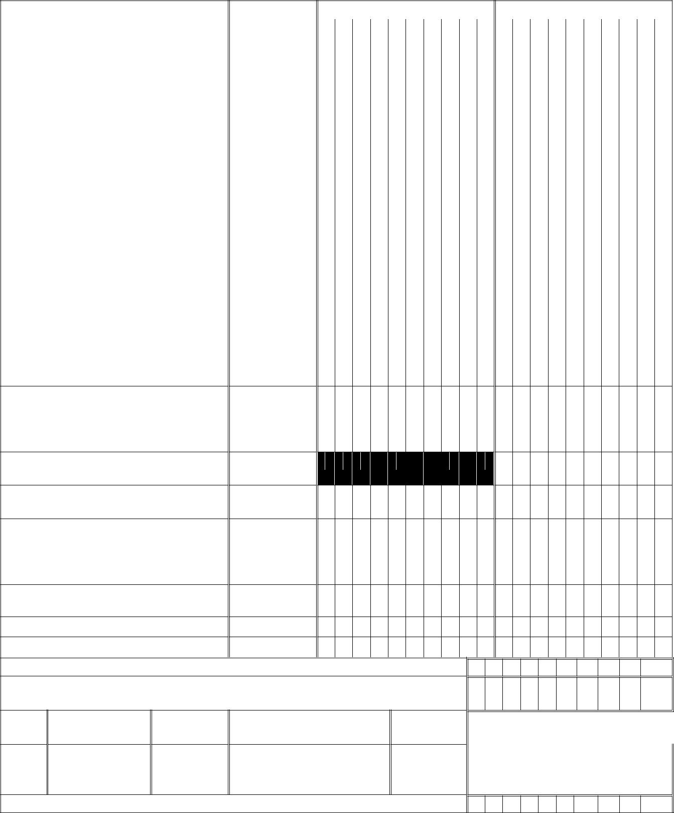
R7 Calculation of Tax for the Quarter |  |  | Rate of Tax |  | Turnover |  | Tax Payable
R7.1 | Turnover of Goods sold against |  | 2%
C-Form( excluding sale of capital
assets) |  | [Goods specified in Schedule
III of DVAT Act ( i.e.@ 5%)]
R7.2 | Turnover of Goods sold against |  | 2%
C-Form [ goods not specified in any of
the Schedules of DVAT Act ( i.e.@
12.5%)]
R7.3 | Turnover of Goods sold against |  | 2%
C-Form [Fourth Schedule of DVAT
ACT ( i.e.@ 20%)]
R7.4 | Turnover of Goods (specified in |  | 1%
Schedule II of DVAT Act )
R7.5 | Turnover of Goods sold without |  | 5%
C-Form [Goods specified in Schedule
III of DVAT Act ]
R7.6 | Turnover of Goods sold without |  | 12.5%
C-Form |  | [ goods not specified in any of
the Schedules of DVAT Act]
R7.7 | Turnover of Goods sold without |  | 20%
C-Form [Fourth Schedule of DVAT Act
R7.8 Total (R7.1 to R7.7)

R7.9 Less: Amount of tax on value of sold goods return under CST Act, for the previous tax periods but not older than six months

R7.10 Balance Tax Payable (R7.8-

R7.9)

R7.11 Balance carried forward from previous tax period

R7.12 Adjustment of Excess Tax Credit under DVAT towards CST liability (refer item R9.1 of Form DVAT-16)

R7.13 Net Tax

[R7.10 – (R7.11 + R7.12 )]

R 7.14 Interest , if payable

R.7.15 Penalty, if payable

R7.16 Balance Payable | (R.7.13+R7.14 +R7.15)

R7.17 Less : Amount deposited by the dealer (attach proof of payment with Form

DVAT-56)

S.No. Date of deposit | Challan | Name of Bank and BranchAmount

No.

R8 Net Balance* (R7.16- R7.17)

* The net balance should not be positive as the amount due has to be deposited before filing the return.

IF THE NET BALANCE ON LINE R 8 IS NEGATIVE, PROVIDE DETAIS IN THIS BOX

R9 Balance brought forward from line R8 (positive balance of R8)

R9.1 Adjusted against liability under Local Act

R9.2 Balance carried forward to next tax period

 | Year | Sale against |  | Amount | Amo | Amount | Tax rate wise |  | Amount
R10 Year-wise details of | (quarter |  |  | of Total | unt | of | break up of |  | paid on
pending forms/ declarations. | wise for |  |  | Sale | of | Forms/D | missing forms |  | account of
 | the last |  |  |  | Form | eclaratio |  |  | missing
 | four |  |  |  | s/De | ns |  |  |  | forms
 | years |  |  |  | clara | Pending | Tax | Am | Ta |  | Inte
 | complete |  |  |  | tions |  | Rate | oun | x |  | rest
 | d and |  |  |  | recei |  | (DVA | oun | x |  | rest
 | d and |  |  |  | recei |  | (DVA | t
 | upto the |  |  |  | ved |  | T) | t
 | current
 | quarter)
 |  | ‘C’ Form (Excluding
 |  | sale in transit against
 |  | E1/
 |  | E2)
 |  | ‘F’ Form
 |  | ‘H’ Form
 |  | ‘I’ Form
 |  | C + E1/E2 | C Form
 |  |  | E1/
 |  |  | E2 Form

R 11. Utilisation Account of Declaration Forms issued in Advance before filing of the tax return

Return |  |  |  | Name, | Amou | Item |  | Date of
Return | Type | Date of |  | Name, | nt for | Item |  | Date of
Period – | Type | Date of | Advanc | addres | nt for | descripti | Invoice | issue to
Period – | of | Issue of | Advanc | addres | which | descripti | Invoice | issue to | Amount for which form
(Quarte | of | Issue of | e Form | s & RC | which | on with | Number & | Selling | Amount for which form
(Quarte | For | Advanc | e Form | s & RC | form | on with | Number & | Selling | was utilised
r and | For | Advanc | Number | No. of | form | classificat | Date | Dealer/ | was utilised
r and | m | e Form | Number | No. of | was | classificat | Date | Dealer/
Year) | m | e Form |  | Seller | was | ion code |  | Consigner
Year) |  |  |  | Seller | issued | ion code |  | Consigner
 | (To be auto-generated by the system) |  |  |  |  |  | (To be filled by the dealer)
1 | 2 | 3 | 4 | 5 | 6 | 7 | 8 | 9 | 10

R12. Verification

I/We __________________________________________ hereby solemnly affirm and declare that the information given hereinabove is true and correct to the best of my/our knowledge and belief and nothing has been concealed there from.

Signature of Authorised Signatory |  |  |  |  |  |  |  |  |  |  |  | ______________________________________________________
Full Name (first name, middle, surname)
 |  |  |  |  |  |  |  |  |  |  |  | _____________________________________________________
 |  |  |  |  |  |  |  |  |  |  |  | ______________________________________________________
Designation/Status
 | Place
 | Date
 |  | Day |  |  |  |  | Month |  |  |  |  |  | Year

INSTRUCTIONS FOR FILLING OF FORM 1

- Please complete all the applicable fields in the Form 1 and leave other fields blank.

- Copies of ‘C’ Portion of the Challan shall be attached to the Return Verification Form DVAT-56, wherever applicable, without which the Return would be treated as incomplete.

- All figures should be rounded off to the nearest rupee.

- The value of goods returned for sales made during the current tax period should be shown in R5 and the amount of tax on value of sold goods returned under CST Act, for the previous tax periods, but not older than six months, should be reflected in R7.9.

- Sale against H Forms under section 5(3) under the Central Sales Tax Act should be reported in R6.1(3). The sales made against H Form by a Delhi dealer to the Exporter in Delhi should be reported in Form DVAT-16.”.

By order and in the name of the Lt. Governor of the National Capital Territory of Delhi,

(H.P. Sharma)

Dy. Secretary (Infra)

No.F.3(16)/Fin.(Rev-I)/2013-14/dsVI/787 Dated the 20.09.2013

Copy forwarded for information to:-

- The Principal Secretary (GAD), Government of NCT of Delhi in duplicate with the request to publish the notification in Delhi Gazette Part-IV (extraordinary) in today’s date.
- The Principal Secretary to the Hon’ble Lieutenant Governor, Delhi.

- The Principal Secretary to the Hon’ble Chief Minister, Government of NCT of Delhi, Delhi

Sachivalaya, I.P. Estate, New Delhi.

- The Principal Secretary (Finance), Government of NCT of Delhi, Delhi Sachivalaya, I.P. Estate, New Delhi.
- The Commissioner, Value Added Tax, Vyapar Bhawan, I.P. Estate, New Delhi.

- The Secretary to Finance Minister, Government of NCT of Delhi, Delhi Sachivalaya, New Delhi .

- The P.A. to the Leader of Opposition, 29, Delhi Legislative Assembly, Old Secretariat, Delhi.

- The Additional Secretary (Law), Government of NCT of Delhi, Delhi Sachivalaya, I.P. Estate, New Delhi.
- OSD to Chief Secretary, Government of NCT of Delhi, Delhi Sachivalaya, I.P. Estate, New Delhi.

- The Registrar, Delhi Value Added Tax Appellate Tribunal, Vyapar Bhawan, I.P. Estate, New Delhi.

- VAT Officer (Policy), Department of Trade and Taxes, Government of NCT of Delhi, Vyapar Bhawan, New Delhi.
- Programmer (EDP) for uploading the notification on the website of the department.

- Guard File.

(H.P. Sharma)

Dy. Secretary (Infra)

